TOYO TIRES King of Europe 2006
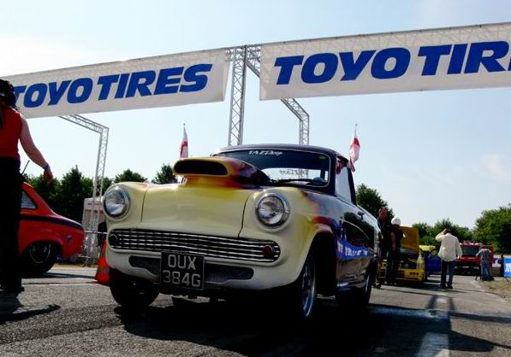Belgium, Chimay, Saturday night at the racetrack. Fuel and tires, pumped adrenalin, baited breath, waiting to see who will take Paul Vlasblom’s crown to be become the new “King of Europe”.
As many enthusiasts and spectators would attest, this event is such a mindblower that they would do anything to be there, and their dedication grows year on year. One reason being that this year the TOYO TIRES King of Europe Drag and Drift events were staged side-by-side, building the excitement to a level of absolute fever pitch. The crowd numbers bore testament to this new obsession, with figures well up over 10% on last year, as over 9,000 agitated, hopeful visitors crammed the stands for both Drag and Drift phenomenon.
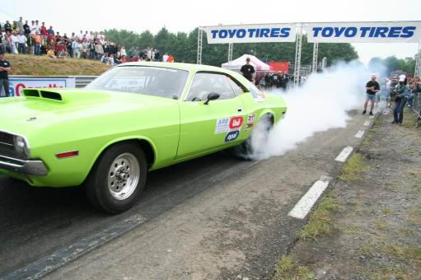The TOYO TIRES King of Europe Drag 2006 made its stand as the original European 1/4-mile drag shot for street legal cars. This experience has continued to heat up each year, and 2006 was a real triumph. After technical inspections and qualifications, all the drivers burned through downtown Chimay in a parade-style test drive to prove their compulsory “Street Legal” status. Back on the track, Vincent Perrot performed two demos with his new 6000bhp JetCar Mach2 after which Peter Schofer, one of the best Drag Racers in Europe, gave his premier demo race in a Top Methanol Dragster.
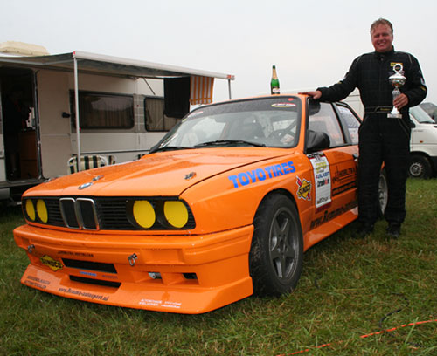The Big Boys in the arena battled it out down to the final four; high contenders Stefan Gustafsson of Sweden in his Chevrolet Camaro, Kevin Preston of the UK in a A60 Pick Up and Luca Lodi of Italy with a Lancia Delta were all defeated by Nigel Parkin of the UK, who earned the title of King of Europe Dragster behind the wheel of his Jaguar XJS. Congratulations King Nigel!

On the last day, even as the weather changed for the worse, the spectators refused to give in, and stayed firmly in their seats, growing - if anything - even wilder with excitement as a two-hour AC/DC tribute by MachineGun finished their incredible night.
With 9 points in the pocket, Remmo Niezen takes the lead of the championship!!!
The Drifters did not stay long out of the limelight though. Many of the onlookers in the crowd were newly acquainted with Drift, experiencing this thrill for the first time. The response was fantastic, with a really fresh, exciting atmosphere.
As the attraction has built across Europe, the TOYO TIRES King of Europe Drift Series 2006 is now being staged in 5 rounds in 5 separate locations. After the opening round in Poznan, Poland, an incredible show with over 30 drivers and more than 4,000 spectators, the championship pushed on to the 2nd round of the series in Chimay, Belgium with a new high of 65 participants of Europe’s best-known drifters.
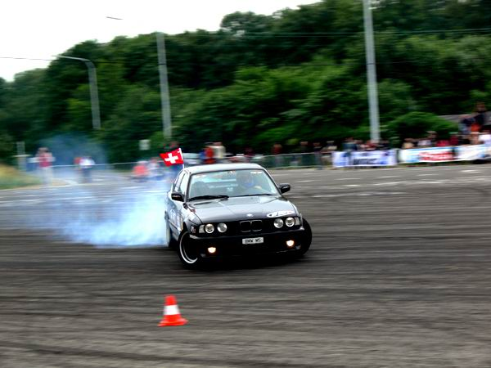The drivers were mainly from the Benelux area but also from France, Switzerland, Poland and Nordic. After qualifications and classic Twin Battle finals, Olaf Commijs finished 4th after beating the unknown BMW M5 drifter Franck Lagalice, but failed against Mike De Bruyn in the semi-final. Yves Faber from Luxemburg in his Nissan S14 pushed hard all weekend, but ended up taking 3rd place. Mike de Bruyn was close to winning; he showed a very high drifting level, and finished in 2nd place. Remmo Niezen and his orange BMW M3 impressed everybody from start to finish, and was simply unstoppable. With 9 points in his pocket, Remmo took the lead of the championship and won the second stage of the battle head-on!!
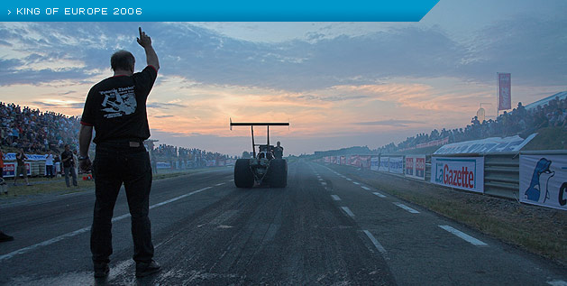
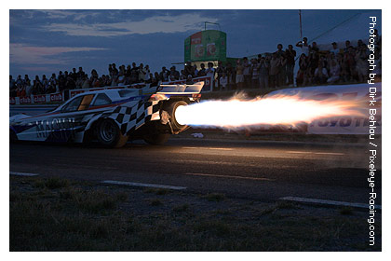It’s true what they’re saying; Drag and Drifting are growing up, like strong-headed, rebellious teenagers! Round 3 & 4 of the TOYO TIRES King of Europe Drift Series 2006 will be held in the Nordics before a fast-growing alliance of drift enthusiasts and skilled drivers. The 3rd heat will take place on July 15th in Alastaro, Finland, followed by a 2-day tournament in Björkvikring, Sweden, on July 16th. Round 5 will be held in Germany, but the exact date and location are still under wraps. Keep your eyes and ears open, and make sure you’re one of the first to be there!

Photo By TT Creation + Dirk Behlau【www.pixeleye-racing.com】

